
BTMNA File-To-Queue API and Technical Specification
Version 1.0
Bank of Tokyo-Mitsubishi, Ltd.
34 Exchange Place
Plaza 3
Jersey City, NJ 07311

About This Document
This document provides conceptual, procedural, and reference information regarding the development and support of the File-To-Queue application.
Audience
BTMNA IDT managers, developers, and systems staff members who develop and support the File-To-Queue application should read this guide.

© 2002 Bank of Tokyo-Mitsubishi, Ltd.
All rights reserved. No part of this publication may be reproduced, transmitted, transcribed, stored in a retrieval system, or translated into any language, in any form by any means, without the written permission of Bank of Tokyo-Mitsubishi, Ltd. The information contained in this document is confidential and proprietary.
V:\Glos_Sys on ‘Nyex2011’\ISG_Doc\IDT\FileToQueueTechnical Specification.Doc
Location of Document:

Contents

Contents iii

1. Revision History 1

2. Introduction and Description 2

2.1 File Types 2

2.2 File-To-Queue Components 2

2.3 Security and User Upload Access 2

2.4 Active Server Pages and Methods 3

2.4.1 Active Server Pages 3

2.4.2 Objects and Methods 5

3. Standards and Conventions 6

3.1 Visual Basic Coding Conventions 6

3.2 VBScript Coding Conventions 6

3.3 Posting Acceptor Whitepaper 6

4. Source Files and Libraries 7

5. Technical Design 8

5.1 System Architecture: An Overview 8

5.2 Visual Basic Objects and Methods 9

5.2.1 The clsUPLDSecurity Object 9

5.2.2 The clsQueueCalls Object 10

5.3 How File-To-Queue Works: Methods Invoked 13

5.4 Stages in the File Upload Process 13

5.5 Microsoft’s Posting Acceptor 16

5.5.1 HTML Considerations for The Posting Acceptor 16

5.6 Establishing Database Connections 17

5.7 Database Design 18

5.7.1 The TUPA_USER Table 18

5.7.2 The TUPA_QNME Table 18

5.7.3 The TUPA_EPRF Table 19

5.8 Establishing User File Upload Access 20

6. Installing File-To-Queue 21

6.1 Installation Prerequisites 21

6.1.1 Server Requirements 21

6.1.2 Client Requirements 21

6.2 Deploying and Configuring File-To-Queue 21

6.2.1 Deploy File-to-Queue 21

6.2.2 Set Permissions 22

6.2.3 Allow read, and execute access to the Scripts Directory 22

6.2.4 Allow read, and write access to the Uploadedfiles Directory 23

6.2.5 Set NTFS Permissions 23

7. References 24

Revision History

Revision Number | Release Date | Author(s) | Changes
1.0

Introduction and Description
File-To-Queue is an Intranet-based application developed by BTMNA’s Intranet/Internet Development Team (IDT) for the TMS department. The TMS department uses the File-To-Queue application to upload xml or flat files that contain stock transaction records. These records are fed onto a queue processed by MQSeries. The BESS application then accesses the queue and uses the uploaded data to process bank payment transactions.

File Types
The File-To-Queue application can upload two types of files: XML files or flat files (text). The xml files must be valid, but the flat files do not have to have a specific format. However, the file type and length must be predefined in the DB2 database.

File-To-Queue Components
The File-To-Queue application consists of the following components:
- Active Server Pages that presents users with an interface allowing them to select and upload files.
Note: The application uses Microsoft’s Posting Acceptor (cphost.dll) to actually transfer the data to the queue. (For more information, see the section called Stages in the Upload Process.)
- Server-side, Visual Basic Components (Objects and Methods) that activate the upload process by verifying user access, verifying the type of file along with its length, and then writing the data to queue.
- DB2 Database tables that contain user account and file information.
- MQSeries queues which hold the data until they is accessed by the BESS application.

Security and User Upload Access
File-to-Queue users access an Active server page (ASP) where they can browse their PCs and select the file that they want to upload. However, the file name and the file length as well as the users U number must exist in a DB2 database before the user can upload data. File-To-Queue Administrators use the Maintenance function on the F2Qmain.asp page to grant and delete user access rights.
For more information on File-To-Queue security and user access privileges, see the section on Database Design in this document.

Active Server Pages and Methods

Active Server Pages
Written in HTML, Visual Basic (VB), and VBScript, File-To-Queue contains the following key Active Server Pages:
- F2Qmain.asp
- F2QuploadProcess.asp
- F2QprocessFile.asp

F2Qmain.asp
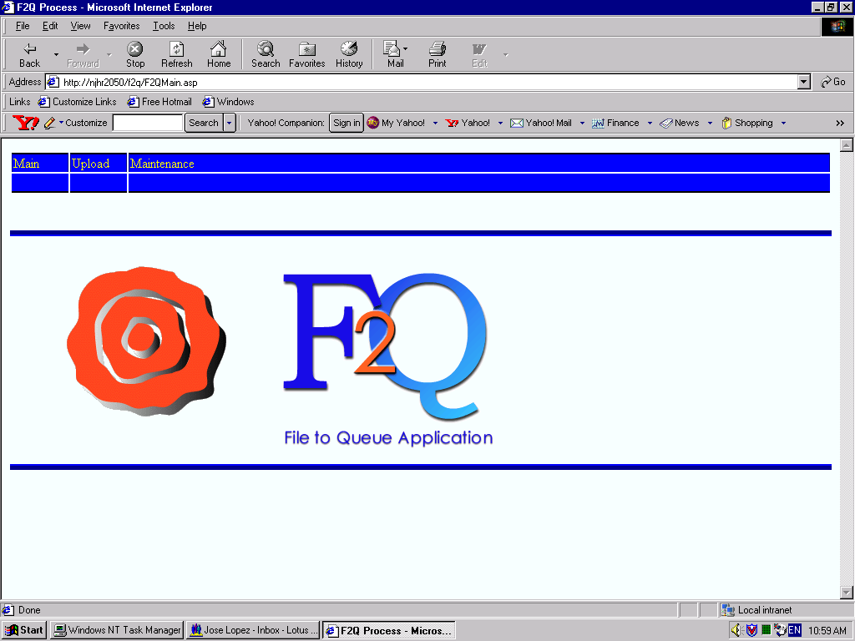
This page displays the main File-To-Queue splash page that users see when they first access the application. The following illustrates the F2Qmain.asp page:

F2QuploadProcess.asp
This page allows users to browse and select files on their PCs for upload. Once they select a file, they click Submit to activate the upload process.
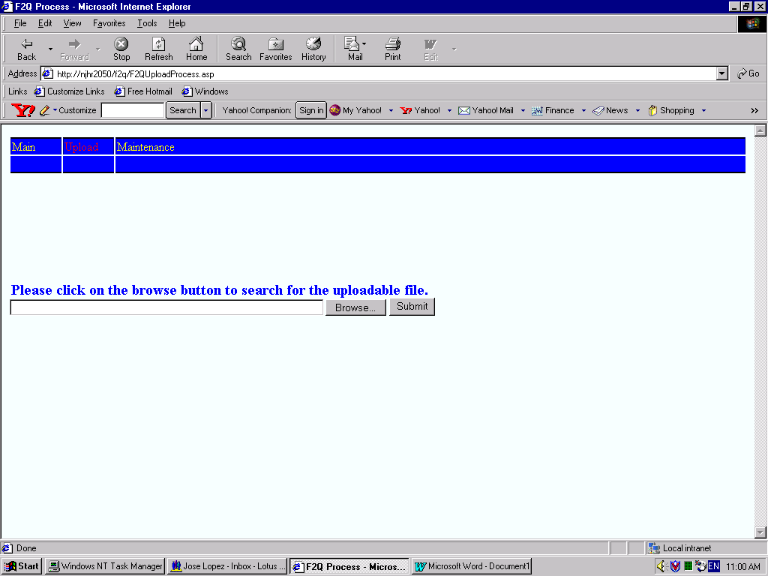

File Upload Information Page
After a file is uploaded, read, and processed, the file statistics are displayed in the Upload Information page as illustrated below:
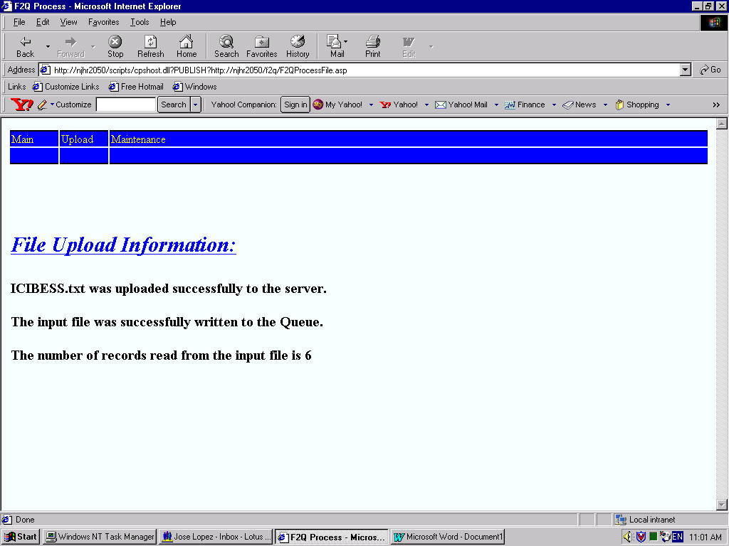

Objects and Methods
The File-To-Queue application employs the following key methods contained in the clsQueueCalls objects.
- VerifyFile: Verifies user file upload access information and file type.
- InitMQS: Evokes the MQSeries functionality.
- WriteMQSRec: Writes the data to queue.
Fore more information regarding these methods and how they interact, see the section on System Architecture: An Overview in this document. For a complete listing of Objects used in the File-To-Queue application along with their related methods, see the section called Visual Basic Objects and Methods in this document.

Standards and Conventions
To ensure that IDT programmers write consistent code, that is readable, extendable, and maintainable, the IDT department uses industry-standard coding conventions for Visual Basic and VBScript.
When writing code, programmers must follow the standards and conventions listed in the sections which follow:

Visual Basic Coding Conventions
For Visual Basic coding conventions and standards, see the following Web site:
http://msdn.microsoft.com/library/default.asp?url=/library/en-us/vbcon98/html/vbconcodingconventionsoverview.asp

VBScript Coding Conventions
For VBScript coding standards and conventions, see the following Web site:
http://msdn.microsoft.com/library/default.asp?url=/library/en-us/script56/html/vbsCodingConventions.asp

Posting Acceptor Whitepaper
For information regarding Microsoft’s Posting Acceptor, see the following Web site:
http://www.webappdeveloper.com/whitepapers/Using%20MS%20Posting%20Acceptor.html

Source Files and Libraries
All source code is maintained in the SourceSafe database, which is on VSSWeb. The VSSWeb SourceSafe database path is:
\\njhr2015\ALL_ISG\Technology\VSS\VSSWeb

Technical Design

System Architecture: An Overview
The server-based components submit queries to the DB2 database via ActiveX Data Objects (ADO), to validate user and file information. If the components validate this information, the application reads and writes the uploaded xml files to the queue.
The following diagram illustrates the basic File-To-Queue‘s architecture along with the various application components.
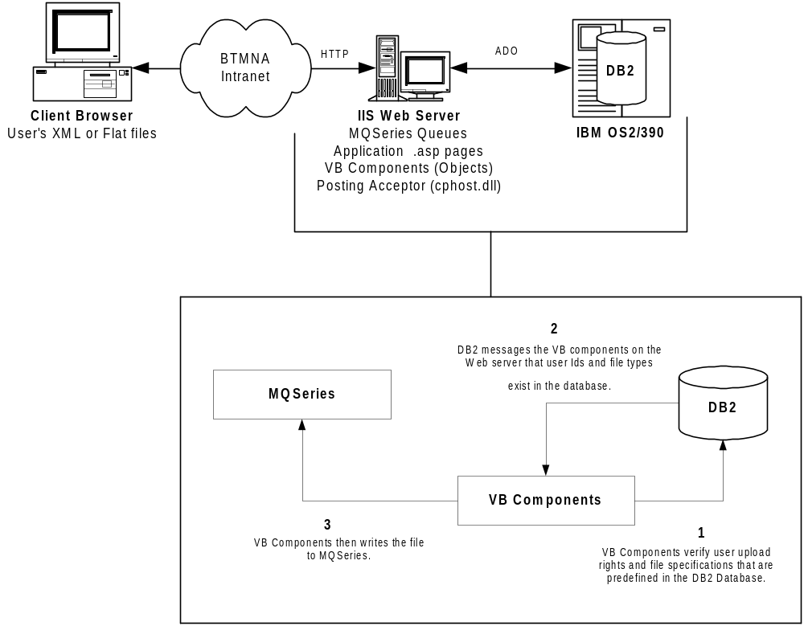For a detailed description of how VB Components (objects and methods) perform the upload, see the section called, Stages in the Upload Process.

Visual Basic Objects and Methods
File-To-Queue employs the following key objects to verify security, check file type, and upload data to the queue:
- clsUPLDSecurity: Validates user access from the Windows NT point of view.
- clsQUEUECalls: Contains methods which validate user and file type data supplied by users against information stored in DB2 database tables.
- MQSeries-specific Methods: These methods, CMQB, CMQCFB, and CMQXB handle queue management.
For a more detailed discussion of MQSeries objects and methods, access the Web site below. This site contains a .zip file with classes pertaining to Visual Basic/MQSeries development. The site provides documentation on the MQSeries classes, and contains example files on how to use those classes.
http://www-3.ibm.com/software/ts/mqseries/txppacs/ma7b.html

The clsUPLDSecurity Object
The following diagram illustrates the methods associated with clsUPLDSecurity. The table below it provides more information regarding input parameters, returns, and exceptions.
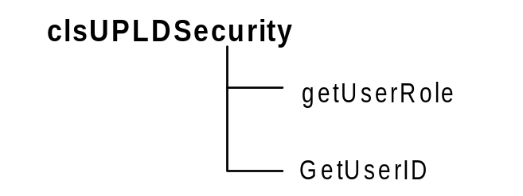
Method | Description | Input Parameters | Returns | Exceptions Thrown
getUserRole | Establishes the user’s role. Example: Admin, User or Developer | None | The Group ID in which the user’s ID resides. | N/A
GetUserID | Retrieves user ID (NT user ID) | None | User ID | N/A

The clsQueueCalls Object
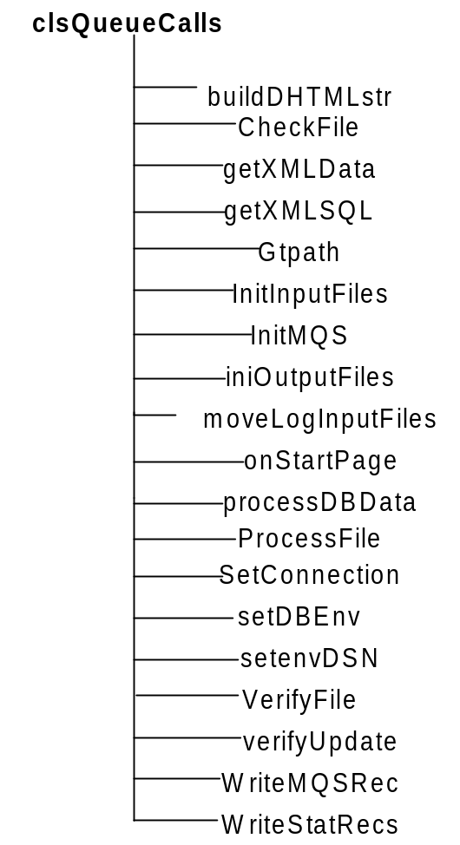The following diagram illustrates the methods associated with clsQueueCalls.

Method | Description | Input Parameters | Returns | Exceptions Thrown
buildCombo | Builds and returns combo box html for a given recordset. | Rst: Recordset to build the combo box  Selid: String value for the selected item in combo box. | String: combobox html | N/A
BuildDHTMLstr | Builds display table HTML for maintenance functionality | Rst: Recordset for table display.  virDir: Virtual Directory path | String: Table HTML | N/A
CheckFile | Verifies file type and processes file to the queue. | Xmlstring: xml to check  virDir: Virtual Directory  Uid: User ID | String: XML | N/A
GetXMLData | Method invokes buildDHTMLstr. | Sqlid: string to identify sql  virDir: virtual directory path | String: Table HTML | N/A
getXMLSQL | Method that reads an xml resource file and returns a sql string. | Sqlid: string to identify sql and return  VirDir: virtual directory of application | String: sql statement | N/A
Gtpath | Returns the path of the application. | pth: file path | String: path | N/A
InitInputFiles | Initializes and opens the input file. | Varfilename: file name | N/A | N/A
InitMQS | Method to initialize MQSeries objects | VirDir:Virtual directory | N/A | N/A
InitOutputFiles | Method initializes and opens the output file | N/A | N/A | N/A
MoveLogInputFiles | Moves the input file to a log directory on the server. | Inputfile: upload file  Outputfile: log file | N/A | N/A
OnStartPage | This method initializes the context session object. | Scontext: Object Scripting Context | N/A | N/A
ProcessDBData | Method uses the command object to update the DB2 database. | SqlTBid: String to identify SQL  XmlDBData: Table parameters  QmgrName: Queue Manager name  VirDir | String: Message to indicate the status of the process. | N/A
ProcessFile | Method verifies user, file type before writing contents to queue. | String: xml | String: xml message | N/A
SetConnection | Opens DB2 connection |  | N/A | N/A
SetDBEnv | Sets the database environment variables for either the Production or Development. | psql: database environment sql | String: database environment sql | N/A
SetenvDSN | Sets the DSN environment variable to either Production or Development. | N/A | String: returns the DSN | N/A
VerifyFile | Verifies file access information. | Xmlstring; parameters that update the database | String: xml message | N/A
VerifyUpdate | Performs maintenance table updates | Xmlstring: xml | String: xml message | N/A
WriteMQSRec | Writes a specified message to the queue | FileRec: data that is written to the queue | N/A | N/A
WriteStatRecs | Write statistic records to a text file. | N/A | N/A | N/A

How File-To-Queue Works: Methods Invoked
The File-To-Queue application is composed of five key methods contained in the clsQueueCalls object:
- VerifyFile
- Checkfile
- InitMQS
- WriteMQSRec
- RelMQSRes

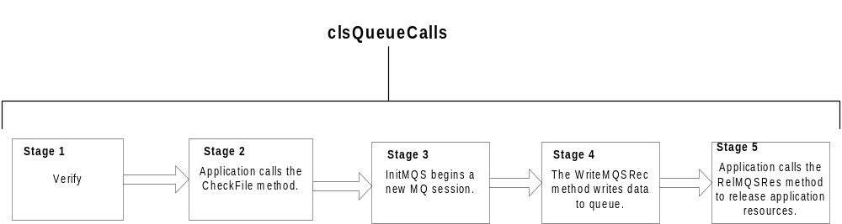The following diagram describes how the methods contained in the clsQueueCalls object perform the upload process. The section, Stages in The Upload Process provides a detailed description.

Stages in the File Upload Process
The following table describes stages of the process File-To-Queue uses to upload data to MQSeries.
Stage | Description
1 | A user accesses the F2QProcessFile.asp page, specifies a file he or she wants to upload and then clicks submit. At this point an HTTP Request is made to F2QcheckAccess.asp which invokes the VerifyFile Method of the clsQueueCalls object. The VerifyFile method is responsible for making a database call via ADO to the TUPA_EPRF, which will confirm the user’s upload privileges for that file. If the user has access to that file, an entry in this table will reflect that. If successful, the upload process will invoke the cphost.dll which will transfer the file from the client’s machine to the server. At this point, the ProcessFile.asp page will be invoked.
2 | The F2QProccessFile.asp page invokes the CheckFile method of the clsQueueCalls object. The CheckFile Method is responsible for making sure that the file is of the correct record length and type. If successful, the program will read the file and write the contents to the MQSeries queue.  If the file is a “Fixed” type, the application writes the file to the queue sequentially.  Note: The application commits the records in the file to the queue only after all records are successfully processed as illustrated by the following sample code:  Do While Not File1.AtEndOfLine  ctTotRecsWritten = ctTotRecsWritten + 1  WriteMQSRec (fileRec & vbLf)  fileRec = File1.ReadLine  Loop  ctTotRecsWritten = ctTotRecsWritten + 1  WriteMQSRec (fileRec & vbLf)  Queue.ConnectionReference.Commit  Set root = xmlProcessFileInfo.createNode("element","FILEINFO", "")  xmlProcessFileInfo.appendChild (root)  Set child = xmlProcessFileInfo.createNode("element", "GOODMESSAGE", "")  child.Text = "The input file was successfully written to the Queue."  xmlProcessFileInfo.documentElement.appendChild (child)  Set child = xmlProcessFileInfo.createNode("element", "NUMRECSPROCESSES", "")  child.Text = "The number of records read from the input file is " & CStr(ctTotRecsWritten)  xmlProcessFileInfo.documentElement.appendChild (child)  CheckFile = xmlProcessFileInfo.xml  - If the file is type “XML”, then open the file and write the contents to the queue.  ctTotRecsWritten = ctTotRecsWritten + 1  WriteMQSRec (fileRec)  Queue.ConnectionReference.Commit  Set root = xmlProcessFileInfo.createNode("element","FILEINFO","")  xmlProcessFileInfo.appendChild (root)  Set child = xmlProcessFileInfo.createNode("element","GOODMESSAGE", "")  child.Text = "The XML input file was successfully written to the Queue."  xmlProcessFileInfo.documentElement.appendChild (child)  Set child = xmlProcessFileInfo.createNode("element",NUMRECSPROCESSES","")  child.Text = "The number of records read from the input file is " & CStr(ctTotRecsWritten)  xmlProcessFileInfo.documentElement.appendChild (child)  CheckFile = xmlProcessFileInfo.xml  If the file is another type, it will not be processed and a message will be returned indicating that the file type is unsupported.
3 | The InitMQS method, which is invoked from the CheckFile Method, creates a new MQSeries session object and attaches to the default MQ Manager. The following sample code illustrates this:  '*** Start new MQ Session  Set QSession = New MQAX200.MQSession  '*** Attach to the default MQ Manager  inputParmRec.QMgrName = getXMLSQL("qMGRName", virDir)  Set QManager = QSession.AccessQueueManager(Trim(inputParmRec.QMgrName))  Set QPutMsgOption = New MQAX200.MQPutMessageOptions  QputMsgOption.Options = MQPMO_SYNCPOINT  '*** Open MQ Queue for reading – shared accessed  Qopts.OpenOptions = MQOO_OUTPUT  Set Queue = QManager.AccessQueue(inputParmRec.Qname, QOpts.OpenOptions)
4 | The WriteMQS method, which is invoked from the CheckFile Method, is responsible for writing to the MQSeries queue. This method will be invoked once for every record in a file. The following sample code illustrates this:  '*** Create new MQMessage  Set QMessage = QSession.AccessMessage  '*** Set the body of the message  QMessage.Format = MQFMT_STRING  QMessage.MessageData = fileRec  '*** Send the Message  Queue.Put QMessage, QputMsgOption
5 | The RelMQSRes method, which is invoked from the CheckFile Method, is responsible for closing and releasing all MQSeries related resources.

Microsoft’s Posting Acceptor
The UploadProcess.asp page invokes Microsoft’s Posting Acceptor (cphost.dll) to transfer the data from the user’s browser to the server. The following sample code illustrates this:

<form enctype="multipart/form-data" method="POST" action="http://localhost/scripts/cphost.dll?PUBLISH?http://localhost/scripts/repost.asp">
Choose a file on your computer: <input type="file" size="40"> <input type="hidden" name="TargetURL" Value="http://localhost/uploads/">
<input type="submit" value="Upload">
</form>

HTML Considerations for The Posting Acceptor
The following are general considerations to follow when constructing the .asp pages referenced by the Posting Acceptor.
- HTML specifications state that when using a file input element, the form's ENCTYPE attribute should be set to "multipart/form-data".
- Setting the form's method attribute to "POST" allows the upload to start on any submit executed for this form.
- The action of the form must be the virtual path to cphost.dll, followed by ?PUBLISH.
- Following the ?PUBLISH, you can add another '?' and the virtual path to another page that will load after the file upload is complete.
- The value of this input element must be the upload directory. There is no need for the user to see this form element, so it is a hidden form.

Establishing Database Connections
The File-To-Queue application uses ActiveX Database Objects (ADO) to connect to the database. The application’s setConnection object establishes the database connection as illustrated in the following sample code:

Set cnn = New ADODB.Connection
Set rst = New ADODB.Recordset Set cmn = New ADODB.Command

cnn.ConnectionTimeout = 100

rst.CursorType = adOpenStatic
rst.CursorLocation = adUseClient

cnn.Open setenvDSN

In the example above, a connection object, a recordset object, and a command object are created. A cnn object is created to establish a connection to the database. The rst object is created to hold a set of records from the database, and the cmn object is created to execute a query against the database.
The setConnection method calls setenvDSN to determine if the database connection will be to the development or production machine. To achieve this, the setenvDSN method uses conditional compilation (#If and #Else directives) as illustrated in the following sample code:
#If DBDSNENV = 0 Then
connstr = Replace(DB2ConnectString, "DB2DSN", "F2Q_Prod", , 1)
#Else
#If DBDSNENV = 1 Then
connstr = Replace(DB2ConnectString, "DB2DSN", "DBDWT01", , 1)
#End If
#End If

Database Design
VB components connect to the DB2 database to verify:
- User ID information
- File type and Length
If information regarding those two elements does not exist in the database, the user will not be able to upload information to queue.
The DB2 database contains the following three tables:
- TUPA_USER
- TUPA_QNME
- TUPA_EPRF

The TUPA_USER Table
The TUPA_USER table contains the User IDs of users who have permission to access the application.
Key | Field | Data Type
Primary, Foreign | ID_EMP | CHAR(07) NOT NULL
 | EMP_LST_CHG | CHAR(07)
 | TMS_LST_CHG | TIMESTAMP

The TUPA_QNME Table
The TUPA_QNME table contains the available queues and Queue Managers where files are written.
Key | Field | Data Type
Primary | NM_QUE | Char (30) NOT NULL
Primary | NM_QUE_MGR | Char (30) NOT NULL
 | EMP_LST_CHR | Char(07)
 | TMS_LST_CHR | TIMESTAMP

The TUPA_EPRF Table
This table contains the employees who have write access or are associated to a particular queue. It will also serve to verify that the uploaded file is of the correct file type and record length.
Key | Field | Data Type
Foreign | EMP_ID | Char (30) Not null
Foreign | NM_QUE | Char (30) not null
 | UPLD_FILE_NM | Char (30)
 | REC_TYP | Char (03)
 | REC_LEN | DECIMAL (05,0)
 | EMP_LIST_CHG | Char (07)
 | TMS_LST_CHG | TIMESTAMP

Establishing User File Upload Access
File-To-Queue Administrators assign the rights for users to upload files by using the Maintenance section of the application. Administrators access this page by clicking Maintenance tab on F2Qmain.asp.
The Maintenance page, F2Qmaint.asp, provides Administrators with an interface to the information stored in the DB2 database. The F2Qmaint.asp page allows administrators to create, modify, or delete User IDs, Queue Names, and Employee Profiles. The following pages illustrate the basic functionality of File-To-Queue’s the Maintenance section:
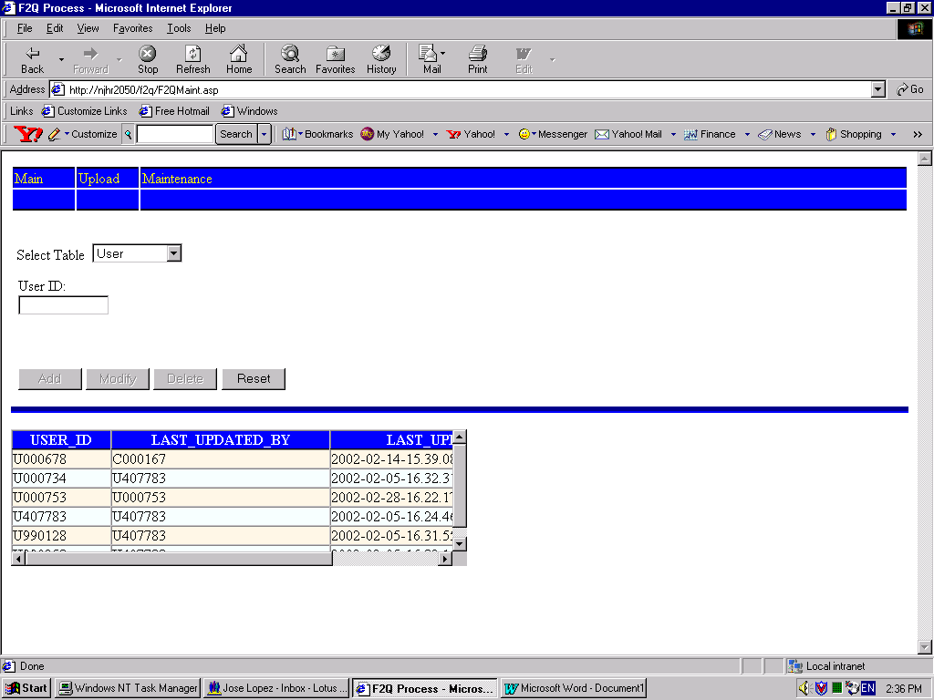
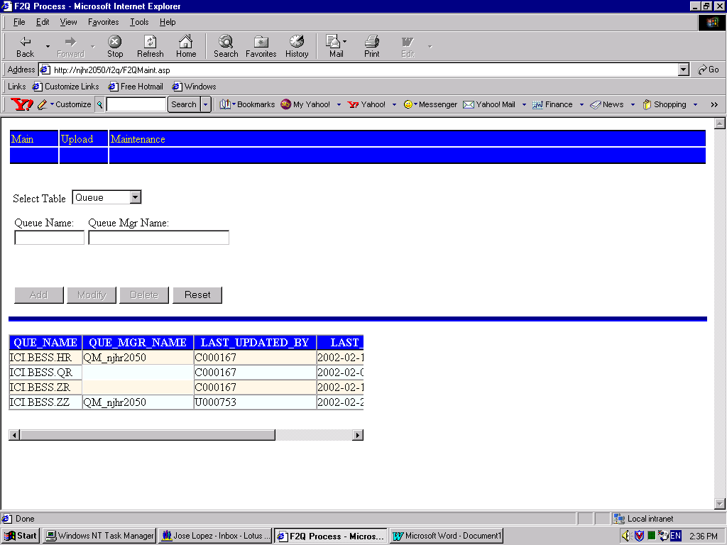
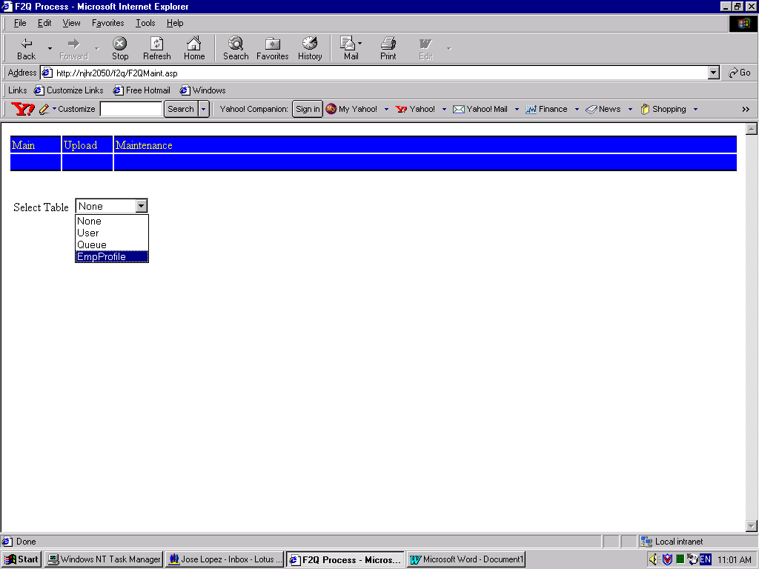
Administrators can select the table that they want to edit.
Administrators can add, modify and delete user information.
Administrators can add, modify, or delete queue information.

For more information on User
and Administrative functions,
see the File-To-Queue User’s Guide.

Installing File-To-Queue

Installation Prerequisites

Server Requirements
The following server-side software is required to run File-To-Queue:
- Microsoft IIS 4.0
- IBM MQSeries Version 5.2
- Microsoft’s Posting Acceptor Application V 7.0.794.7 (This application is located on the Microsoft Visual Studio 6.0-Disk 2.

Client Requirements
Microsoft Internet Explorer 5.0 or greater is required.

Deploying and Configuring File-To-Queue
Sign on to the server using MS Net Meeting and follow the instructions below:

Deploy File-to-Queue

1. Start the Microsoft Management Console (Internet Service Manager)
On Windows NT 4 Server:
Start|Programs>Windows NT 4 Option Pack>Internet Information Server> Internet Service Manager
- Start the Microsoft Management Console (Internet Service Manager)
On Windows NT 4 Server:
Start > Programs > Windows NT 4 Option Pack > Internet Information Server > Internet Service Manager
- Select Microsoft Transaction Server > Computers > My Computer.
- Right-click Shut Down Server Processes.
- Deploy the application in the UploadProcess folder in Microsoft Visual Safe Source (VSSWeb database) to the hosting server/directory.
Note: This can be done from a developer’s machine or server.

Select Web > Deploy.
- Browse to the deployment directory (\\njhr2059\web\f2q) and click Ok.

Set Permissions

- In the F2Q Directory, browse to the Security folder and double-click UPLDMTS.wsf to create the NT groups, components and security roles required by the application.
- Click Ok through the series of prompts.
- Under My Computer, select Packages Installed > UPLD.
- Right-click UPLD and select properties.
- Select the Identity tab and enter the administrator id, password, and confirm password. Apply changes and click Ok to exit.
- Select Internet Information Server > <server name>.
- Select the F2Q Virtual Directory.
- Right click and select Properties.
- Click the Directory Security tab.
- In the Anonymous Access and Authentication Control group, click Edit.
- Confirm that the Allow Anonymous Access checkbox is NOT checked.

Allow read, and execute access to the Scripts Directory

1. Start the Microsoft Management Console (Internet Service Manager)
On Windows NT 4 Server: Start > Programs > Windows NT 4 Option Pack > Internet Information Server > Internet Service Manager.
2. Select Default Web Site > Scripts.
3. Right click Properties.
4. When setting permissions for this scripts directory, check the following:
Allow Read Access, Execute Access.

Allow read, and write access to the Uploadedfiles Directory

1. Start the Microsoft Management Console (Internet Service Manager)
On Windows NT 4 Server: Start > Programs > Windows NT 4 Option Pack > Internet Information
Server > Internet Service Manager

2. Select F2Q Virtual Directory > Uploadedfiles.
3. Right click Properties.
4. When setting permissions for this Uploadedfiles directory, check the following:
Allow Read Access, Write Access

Set NTFS Permissions

1. Open File Explorer and browse to the F2Q directory > Uploadedfiles.
2. Right click Uploadedfiles and select Properties.
3. Select the Security tab > Permissions.
4. Confirm the following groups and their permissions are set to the following:
- UPLDAdmnGrp (must contain BTMNA / WebApp_F2Q_UPLDAdmn) → Full Access
- UPLDDevGrp (must contain BTMNA / WebApp_F2Q_UPLDDev) → Full Access
- UPLDUserGrp (must contain BTMNA / WebApp_F2Q_UPLDUser) → Full Access

References
- For Visual Basic coding conventions and standards, see the following Web site:
http://msdn.microsoft.com/library/default.asp?url=/library/en-us/vbcon98/html/vbconcodingconventionsoverview.asp

- For VBScript coding standards and conventions, see the following Web site:
http://msdn.microsoft.com/library/default.asp?url=/library/en-us/script56/html/vbsCodingConventions.asp

- For information regarding Microsoft’s Posting Acceptor, see the following Web site:
http://www.webappdeveloper.com/whitepapers/Using%20MS%20Posting%20Acceptor.html

